**A PROJECT REPORT**

**ON**

**WA-TER FER-TILIZER AGRI-DRONE**

***Submitted towards the partial fulfillment of the***

***Requirement for the award of the degree***

***Of***

**BACHELOR OF TECHNOLOGY**

**In**

**ELECTRONICS AND COMMUNICATION ENGINEERING**

**PROJECT COORDINATOR: UNDER THE SUPERVISION OF: Mr. Vivek Kumar Gupta Mr. Saurabh Mishra**

**(Assistant Professor, EECE) (Assistant Professor, EECE)**

**SUBMITTED BY:**

**SHYVANSHU MEHRA (Roll No. 180103005)**

**KUSH GAUR (Roll No. 180103001)**

**SAMARPIT BURMAN (Roll No. 200103904)**

**B. TECH – ECE**



**DEPARTMENT OF ELECTRICAL & ELECTRONICS & COMM.**

**ENGINEERING**

**DIT UNIVERSITY, DEHRADUN**

**248009 (INDIA)**

**ACKNOWLEDGEMENT**

We would like to take this opportunity to pay our sincere thanks to **Dr. Sonika Singh (Head, Department of EECE)** who allowed us to carry out this project and provided us with her valuable guidance and suggestion.

We would like to give our sincere thanks and regards to **Mr. Vivek Kumar Gupta (Assistant Professor, Department of EECE)** and **Mr. Saurabh Mishra (Assistant Professor, Department of EECE)** who have always provided us the moral support for completing this work.

We would like to dedicate this work to our parents and all friends who have always supported me in motivational way towards understanding the life and the importance of work.

Last but not least, we would like to thank friends whose toilsome efforts, constant inspiration and affection helped us to complete this work.

Shyvanshu Mehra

Kush Gaur

Samarpit Burman

**ABSTRACT**

A drone is a type of aircraft. The drone is also known as an unmanned aerial vehicle (UAV). The drone is “empty” because it does not require the pilot to fly. A lowly person flies a plane without a plane. Some drones are controlled by a remote control. Some are controlled by computers. Some are being flown thousands of miles away. Drones are available in various sizes and shapes. Many have cameras that take pictures or record video.

Use of plant protection products is one of the most important agricultural activities to to meet the production of hard food all the time. A Drone mounted with sprayer mainly consists of BLDC motors, Li-Po (Lithium polymer)

batteries, pesticide tank, pump, and support frame. Six BLDC motors are included in hexa-copter frame to lift payload capacity. Li-Po battery is used to supply the required current required for the delivery system. A

conical-square water tank was used to hold an insecticide solution. The aluminum supporting frame was suitable used to mount a liquid spray tank, sprayer motor, spray and supporting legs (downhill gears) to get out and stay in a safe place.

|  |  |  |
| --- | --- | --- |
| **Group and Supervisor Details** | | |
| **Name of the students** | **University Roll No.** | **Signature** |
| Mr. Shyvanshu Mehra | 180103005 |  |
| Mr. Kush Gaur | 180103001 |  |
| Mr. Samarpit Burman | 200103904 |  |
|  | | |
| Name of the project guide | Mr. Saurabh Mishra | |
|  | | |
| Title of the project | WA-FER Agri Drone | |
| Signature & Comments of the Guide |  | |

**TABLE OF CONTENTS**

**Content Page no.**

Acknowledgement i

Abstract ii

Group and Supervisor details iii

**CHAPTER 1: INTRODUCTION**

* 1. Introduction
  2. Motivation
  3. Objective
  4. Background
  5. Advantages

**CHAPTER 2: REQUIREMENTS**

2.1Hardware Requirement

2.2 Software Requirement

**CHAPTER 3:**

**CHAPTER 4: GROUNDSTATION**

4.1Working of Ground station

4.2 Circuit Diagram

4.3 Code

4.4 Final Result

**CHAPTER 5:**

**References**

**CHAPTER 1: INTRODUCTION**

**1.1 Introduction**

In India, Agriculture is a major sector of our economy but it is still very short western countries when it comes to adaptability the latest technology for better farm production. Farmers in developed countries have already begun using installed agricultural drones to improve the plant process treatment.

The Hexa-copter, is basically a helicopter with 6 rotors instead of 2 used in a standard helicopter. Hexa-copters have gained great popularity in the field of Unmanned Autonomous Vehicle (UAV) research. " 1/6 weight so that we can use cheap engines. Also, Hexa-copter is easy to build and control and because of their size, they can carry a good amount of load from one place to another.

Currently in India, normal ways to use pesticide spray; sprays excessive, low chemical use, spray uniformity, placement, and coverage; which leads to high cost of pesticides as well environmental pollution. Despite this, boredom will increase in the field application and reduction of placement, which leads to an increase in the cost of such inputs reduced performance in pest control and diseases.

If you look at these facts, a plane without a plane the rolled sprayer is designed the use of pesticide sprays on plants which improves coverage, strengthens chemicals efficient and makes spraying work easier and immediately.

1. Build a drone-mounted spray and check its effectiveness for use of chemicals / pesticides.

2. To make the economy of working with a drone mounted sprayer.

**1.2 Motivation**

The inspiration for this project is Pesticide spraying drones, these are the first drones to give us the idea of ​​making a real drone and is useful for giving water and spraying pesticides to the sown seeds.

Farmers have now started using drones spraying with pesticides, Drones can lift up 1 to 15 liters of pesticide at the same time and cover a very large area at once. This makes it easier for farmers as it just does arrange the drone and let it fly over the arena with the pre-defined patterns to cover the surface with pesticide this turns out to be quick and effective method of spraying pesticides and is as safe as the farmer does not inhaling toxic smoke. In India as individual farms they are small and the use of drones does not help where many companies are armed with drones. This group farmers can come together to hire this type of drone from companies and spray their field.

**1.3 Objective**

**1.4 Background**

The Hexa-copter, also known as the hexa-rotor, is a drone with 6 rotors. The rotors are oriented and positioned in a Hex shape at an equal distance from the center of the Hexa-copter weight. The Hexa-copter is controlled by adjusting the angular velocity of the rotors driven by electric motors.

Hexa-copter is used for monitoring, search and rescue, agricultural purposes and a few other applications. Hexa-copter has received a lot of attention from researchers, as the complexities of hexa-copter have produced a few areas of interest.

* 1. **Advantages**
* It helps to achieve greater yields through efficient resources. It provides a good ROI (Return on Investment).
* Drones are used in large-scale farming to spray water and pesticides because of their remote-control performance.
* Helps to monitor environmental data that helps in smart farming if mounted with camera.
* Helps farmers to inspect their fields quickly and effectively. This saves time in determining the status of the fields.
* It is easy to use them with basic training.
* The latest agricultural drones help collect data that helps improve plant health.

**CHAPTER 2: REQUIREMENTS**

**2.1 Hardware Requirements**

**BLDC Motors**

Selected motors are Brushless DC motors. BLDC motors are commonly used in Hexa-copters of the required size for a project. This type of motor is easy to control and should be mounted on a frame. Each motor consists of an endless magnet that surrounds a steady armature. BLDC motors offer a few advantages over DC motors mixed. Among the advantages are increased torque per weight, reduced noise, greater reliability, longer life and increased efficiency.

Advantages of brushless motor over engines combined with high power-to-weight ratio, high speed, approximate speed control (rpm) and torque, high efficiency, and low maintenance. Brushless motors find applications in areas such as computer peripherals (disk drives, printers), hand-held electric tools, and vehicles ranging from airplane models to cars. In modern washing machines, brushless DC motors allow the replacement of rubber belts and gearboxes with a straightforward drive design.

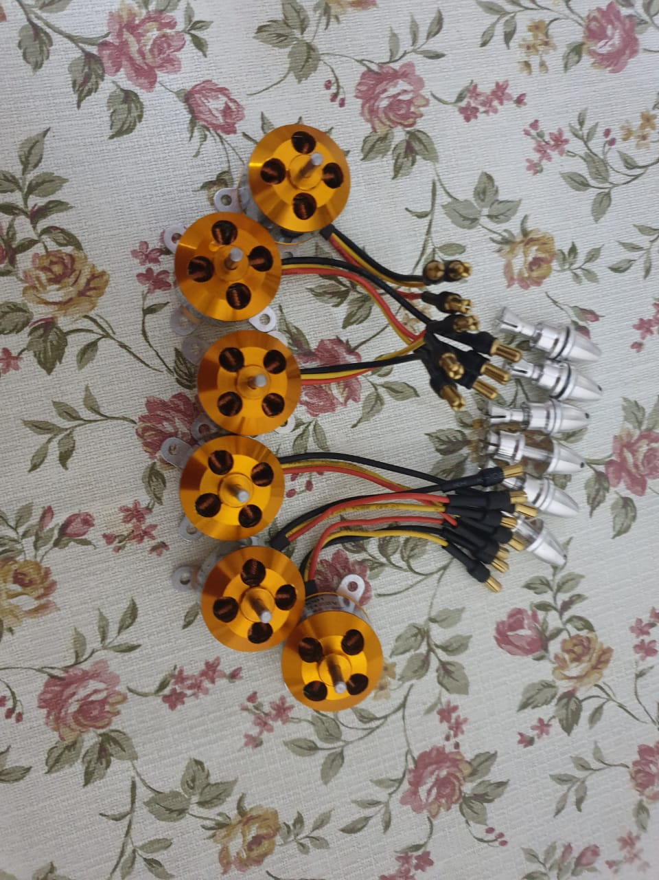

Fig. 2.1 BLDC Motors

**Electronic Speed Controller (ESC)**

Electronic speed control (ESC) is an electronic circuit that controls and controls the speed of an electric vehicle. It can also provide engine deceleration and dynamic braking. Small electric speed controllers are used in electrically controlled radio models. Full-size electric vehicles also have systems for speeding their vehicles.

Electronic speed control follows the speed reference signal (located on the throttle lever, joystick, or other hand-held input) and changes the switching rate of the field effect transistors (FETs). By adjusting the work cycle or changing the frequency of the transistors, the speed of the vehicle is adjusted.

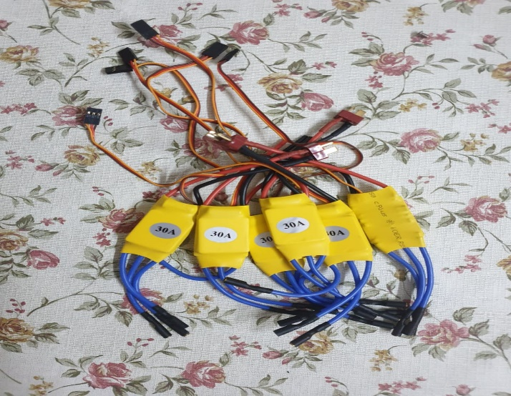

Fig. 2.2 ESC (Electronic Speed Controller)

**Arduino Nano**

The Arduino Nano is a small, complete, and easy-to-use bread board based on ATmega328P released in 2008. It offers the same connectivity and Arduino Uno board details in a small way.

The Arduino Nano is equipped with 30 men's I / O headsets, in a DIP30-like configuration, which can be configured using the Arduino Software integrated development environment (IDE), which is common to all Arduino boards and works both online and offline. The board can be powered by a Micro-USB type B cable or a 9 V battery.

Specifications:

* Microcontroller ATmega328
* Operating Voltage (logic level): 5 V
* Input Voltage (Recommended): 7-12 V
* Input Voltage (limits): 6-20 V
* Digital I/O Pins: 14 (of which 6 provide PWM Output)
* Analog Input Pins: 8
* DC Current per I/O Pin: 40 mA
* Flash Memory 32 KB (ATmega328) of which 2 KB used by bootloader
* SRAM: 2 KB (ATmega328)
* EEPROM: 1 KB (ATmega328)
* Clock Speed: 16 MHz

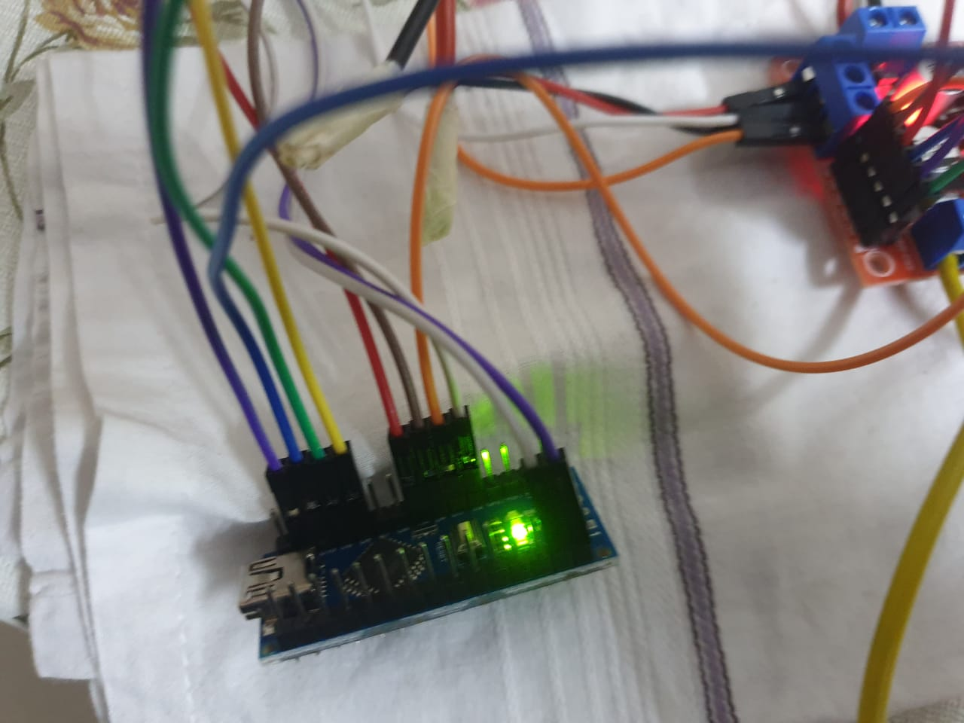

Fig.2.3 Arduino Nano

**L298N Motor Driver**

The L298N is an integrated monolithic circuit in the 15 leading packages of Multi watt and PowerSO20. It is a high-powered, high-capacity full-time bridge driver designed to accommodate TTL standard sand drive loads such as relays, solenoids, DC and pressing motors. Two enable inputs are provided to enable or disable the device without input signals. The emitters of the lower transistors of each bridge are connected together and the corresponding external terminal may be used to connect the external sensor resistor. Additional Supply input is provided for the brain to operate at low voltage.

Specifications:

* Driver Model: L298N 2A
* Driver Chip: Double H Bridge L298N
* Motor Supply Voltage (Maximum): 46V
* Motor Supply Current (Maximum): 2A
* Logic Voltage: 5V
* Driver Voltage: 5-35V
* Driver Current:2A
* Logical Current:0-36mA

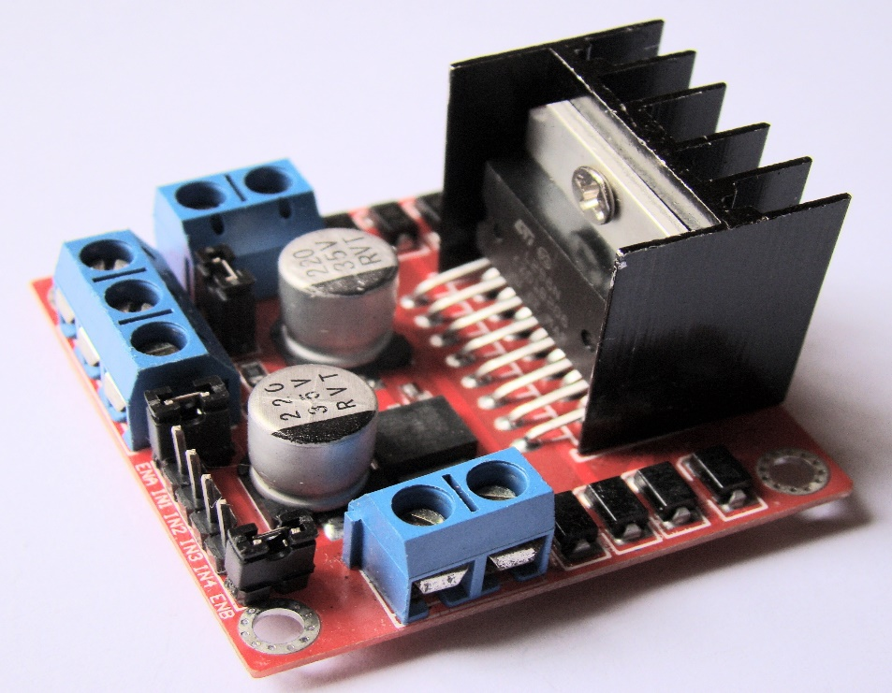

Fig.2.4 L298N Motor Driver

**KK Board 2.1.5 Flight Controller**

KK 2.1.5 packs new energy acquired through updated sensors, memory and theme pins. KK 2.1 is the next evolution of the first-generation KK flight control boards and was built from the ground up to bring a more sophisticated aircraft to everyone, not just professionals. LCD screen and built-in software make installation and setup easier than ever. The original KK gyro system has been updated to the amazing sensitivity of the 6050 MPU making this the most stable KK board ever and adds additional auto level functionality. At the heart of KK2.1 is the ATMEL Mega 644PA 8-bit AVR RISC-based microcontroller with 64k memory. Drawing A useful piezo buzzer is also installed on the board to get a sound warning when it opens and disables the board, which can be supplemented with LED for visual signature. KK 2.1.5 has two 5V electric buses. The first 5V bus is common to all receiver inputs, outputs 1 (M1) and editor ports. This bus enables the KK2.1.X processor and requires as much cleanliness as possible (i.e., no noise from servos). The second 5V bus is typically out of out 2 to 8 (M2 to M8) only.

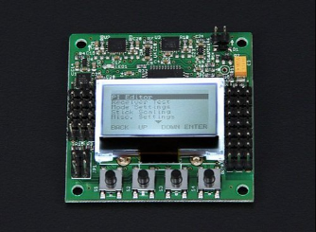

Fig.2.5 KK 2.1.5 Flight Controller

**LiPo Battery**

Lithium Polymer batteries (henceforth known as “LiPo” batteries), are the newest type of batteries used today in many consumer electronics. They have been thriving in the radio control industry over the past few years, and are now becoming the most popular option for anyone looking for long-term and high-energy moments. As with other lithium-ion cells, LiPo works by the principle of coupling and separation of lithium ion from positive electrode material and negative electrode material, and liquid electrolyte providing a conductive medium.

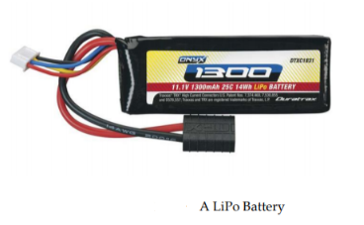

Fig.2.6 LiPo Battery

**Connecting Wires**

Connecting wires allow electrical energy to flow from one place to another because electricity needs a place to move. Most connecting wires are made of copper or aluminum.

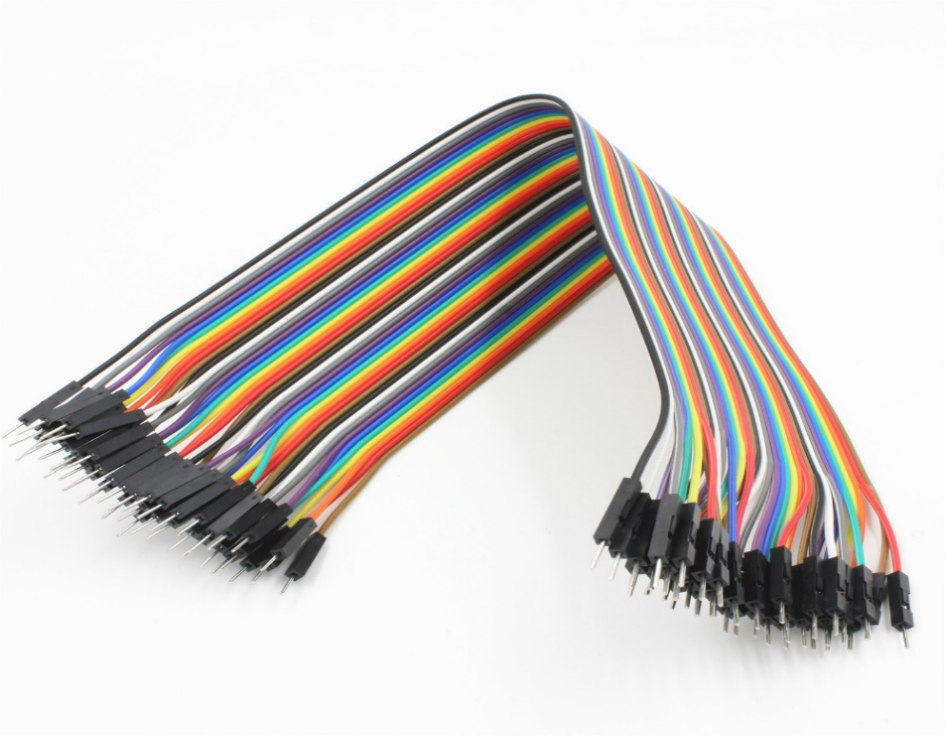

Fig.2.7 Connecting Wires

**Transmitter and Receiver**

The transmitter enables the user to remotely control the aircraft, using 2.4 gigahertz spectrum radio signals. The receivers are electric tools with built-in antennas that capture radio signals from transmitters, and convert them into current alternating pulses. The recipient then generates the information and sends it to the Flight Control Board.

Specifications:

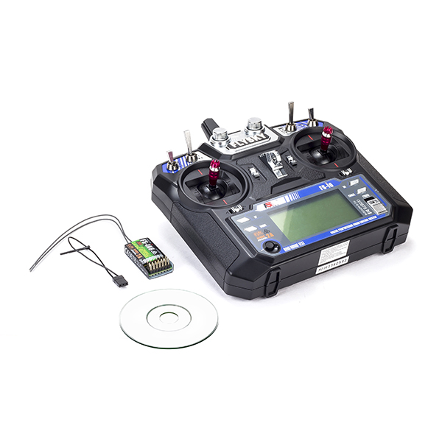

Fig.2.8 Rx Tx

**Breadboard**

A breadboard, or protoboard, is a construction base for [prototyping](https://en.wikipedia.org/wiki/Prototype) of [electronics](https://en.wikipedia.org/wiki/Electronic_circuit). Originally the word referred to a literal bread board, a polished piece of wood used for slicing bread. In the 1970s the solderless breadboard (a.k.a. plugboard, a terminal array board) became available and nowadays the term "breadboard" is commonly used to refer to these.

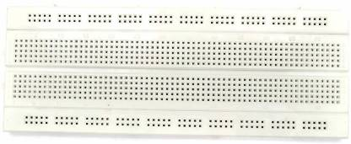

Fig.2.9 Breadboard

**Buzzer**

A buzzer or beeper is a sound signing tool, which can be mechanical, electromechanical, or piezoelectric (piezo for short). Common uses of buzzers and beepers include alarm devices, timers, and user input verification such as mouse click or key click.

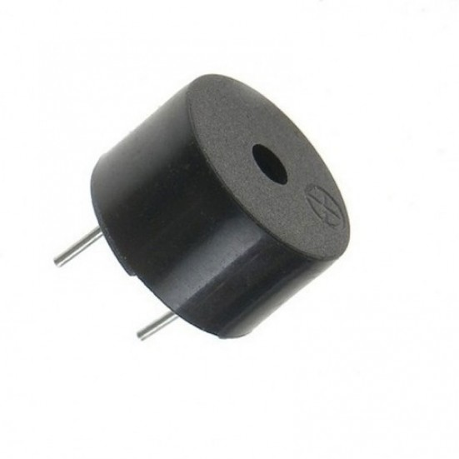

Fig.2.10 Buzzer

**LED**

A light-emitting diode (LED) is a semiconductor light source that emits light when current flows through it. The electrons in the semiconductor reunite with the electron holes, releasing energy in the form of photons. The color of the light (corresponding to the energy of the images) is determined by the force required for the electrons to cross the semiconductor belt gap. White light is obtained through the use of multiple semiconductors or a layer of phosphor that emits light from a semiconductor device.

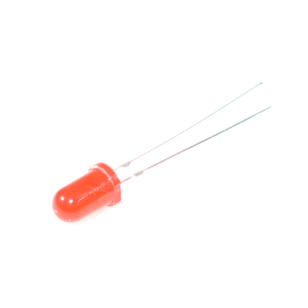

Fig. 2.11 LED

**Arduino Uno**

Arduino Uno is an open-source microcontroller board based on the microchip ATmega328P microcontroller and developed by Arduino.cc. The board is equipped with digital anchor sets and analog input / output (I / O) to which a wide variety of extension boards (shields) and other circuits may be connected. The board has 14 digital I / O pixels (six PWM output), 6 PINM analog I / O pixels, and configured via Arduino IDE (Integrated Development Area), with a USB type B cable. USB cable or 9-volt external battery, although it accepts volumes between 7 and 20 volts.

Specifications:

* Microcontroller: ATmega328P
* Operating Voltage: 5V
* Input Voltage (recommended): 7-12V
* Digital I/O Pins: 14 (of which 6 provide PWM output)
* Analog Input Pins: 6
* DC Current per I/O Pin: 20 mA
* DC current for 3.3V Pin: 50 mA
* Flash Memory: 32 KB (ATmega328P) of which 0.5 KB used by bootloader
* SRAM: 2 KB (ATmega328P)

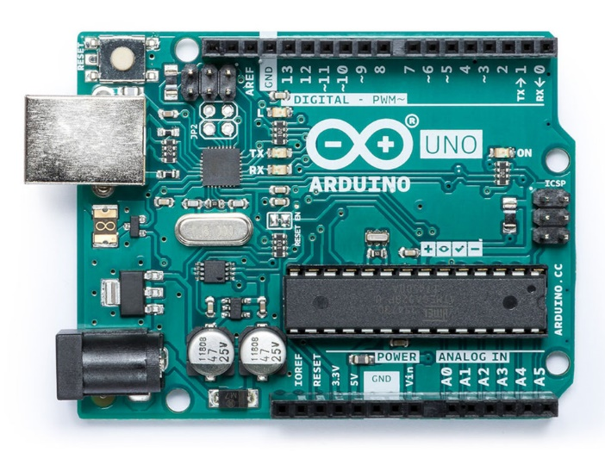

Fig.2.12 Arduino Uno

**Soil Moisture Sensor**

Soil moisture sensors measure the volume of water in the soil. Since a precise gravimetric measure of free-soil moisture requires removal, drying, and weight of the sample, soil moisture sensors measure volume of water volume indirectly through other soil sources, such as electricity resistance, dielectric constant, or interaction. neutrons, as a representative of moisture content.

The relationship between the measured area and the soil moisture should be measured and may vary depending on environmental factors such as soil type, temperature, or electrical conductivity. The radiant microwave radiation is affected by soil moisture and is used for distant sensation in hydrology and agriculture. Portable test kits can be used by farmers or ranchers.

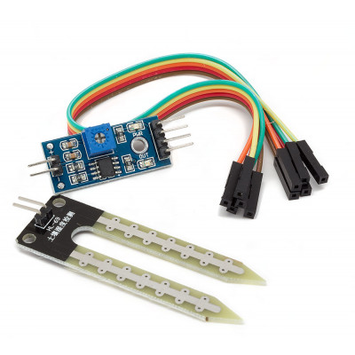

Fig.2.13 Soil Moisture Sensor

**2.2 Software Requirements**

**Arduino IDE**

Open-source Arduino Software (IDE) makes it easy to write code and upload it to the board. This software can be used with any Arduino board.

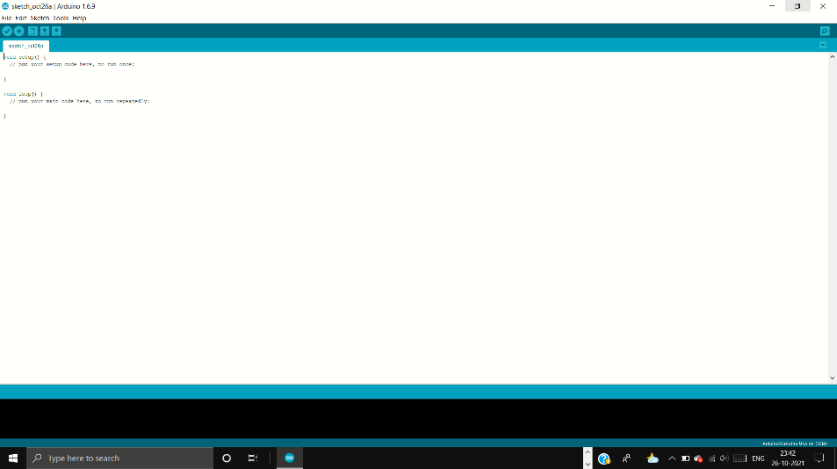

Fig.2.14 Arduino IDE

**Fritzing Software**

Fritzing is an open-source computer program that makes electronic devices as accessible as the creative stuff for everyone. We provide software tool, community website and services in the spirit of Processing and Arduino, promoting a creative ecosystem that allows users to write their own prototypes, share them with others, teach electronic materials in class, and structure and make professional PCBs.

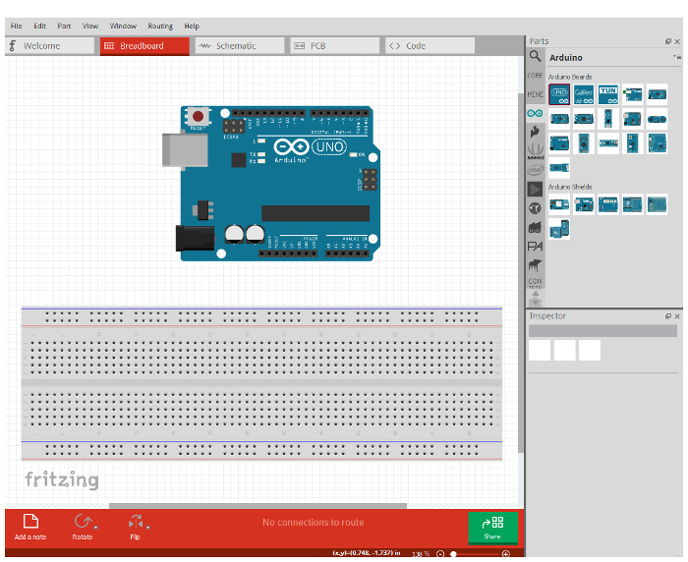

Fig.2.15 Fritzing

**CHAPTER 3: Working of Drone and Flow Chart**

**3.1 Working of Drone**

LiPo (Lithium polymer) batteries (8000 mAh) are used, and they are connected in parallel system to provide the required power for the operation of drone mounted with sprayer. When the drone mounted with spray system is switched on, the receiver starts receiving the transmitted frequency from transmitter/remote control. The transmitter gives commands for takeoff and landing as well as left, right, forward, backward and yaw movements. Electrical power is supplied equally to all the 6 BLDC high speed motors, and they will start to rotate at specified speed, which is controlled by the respective ESC, when the accelerator/throttle is increased or decreased in the transmitter. A pump is connected to the battery system for generating the pressurized spray liquid and the outlet discharge rate can be directly controlled by changing the sprayer motor governor in the transmitter.

**3.2 Flow Chart**

**CHAPTER 4: GROUNDSTATION**

**4.1 Working of Ground station**

The Ground station consists of Arduino board, moisture sensor, LED, buzzer and a battery or power source. The moisture sensor, LED and buzzer will be connected to the Arduino board with the help of connecting wires.

When the code is uploaded in the Arduino with the help of an Arduino IDE. The overall system will work in such a way that when the sensor is dipped in the soil, and the readings is less than the given reading in the code, the LED will be light up indicating that the moisture level is low. As soon as water is poured and the readings gets equal or above the maximum reading, the buzzer will start making sound indicating that enough water is given to the soil.

**4.2 Circuit Diagram**

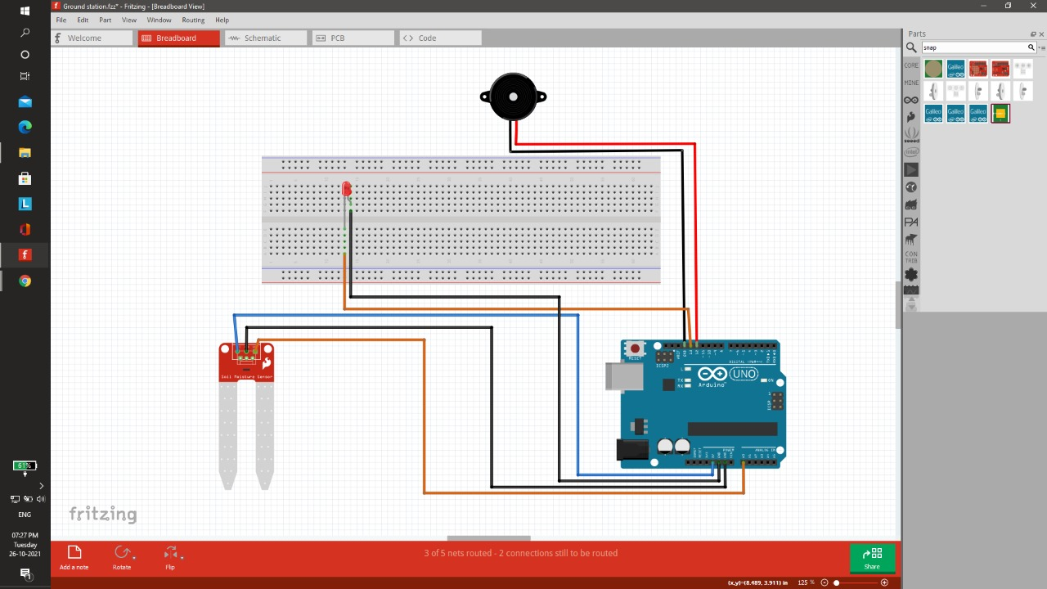

Fig. 4.1 Ground station Circuit

From the Circuit diagram, we can see that the LED positive is connected to pin 13 of the Arduino and the negative to the ground. Buzzer positive is connected to the pin 12 of the Arduino and negative to the ground. Output of moisture sensor is connected to the Analog pin A0 of the Arduino and Vcc is connected to 5v pin of the Arduino, and ground to the ground of Arduino. The Arduino is powered by a 9v battery.

**4.3 Code**

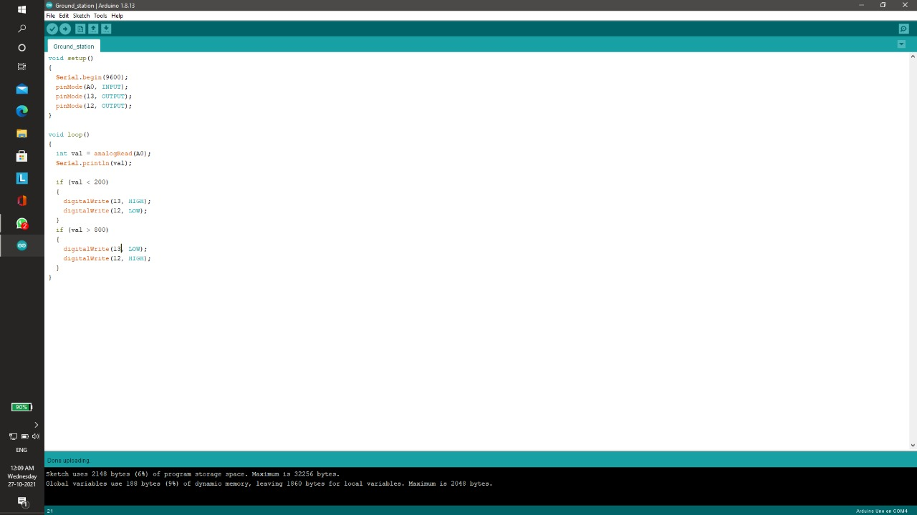

Fig. 4.2 Ground station Code

**4.4 Final Result**

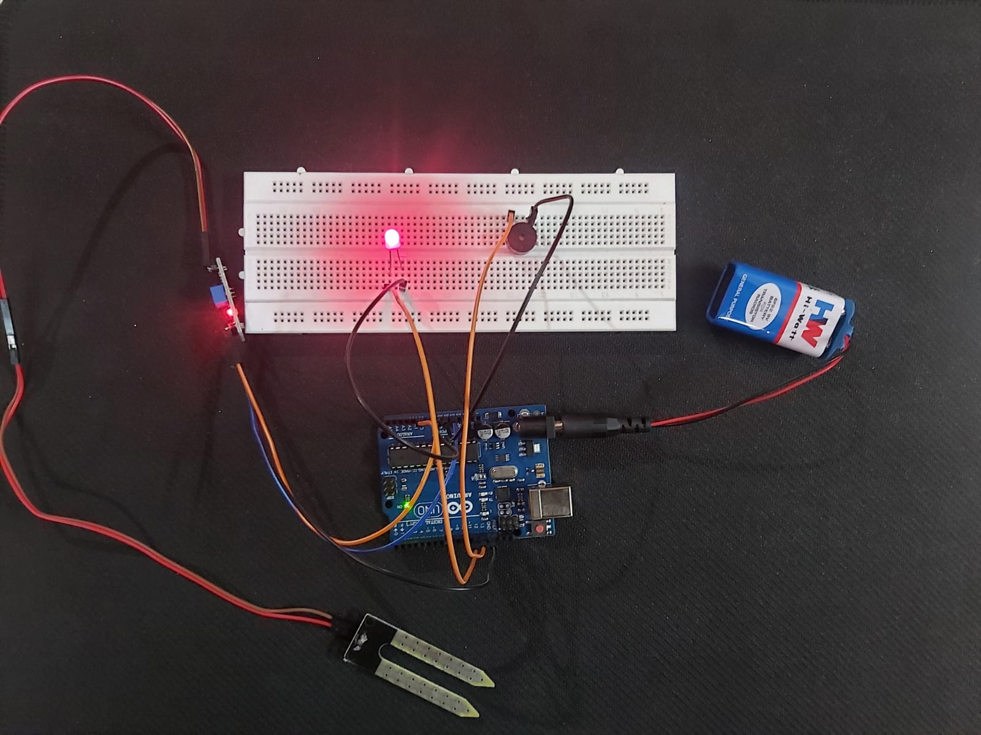

Fig. 4.3 Groundstation